**Classroom Activity: Install Express**

**1.** **Initialize a New Node.js Project**:

* Open your terminal.
* Create a new directory for your project and navigate into it.

mkdir food-delivery-app

cd food-delivery-app

* Initialize a new Node.js project with default settings.

npm init -y

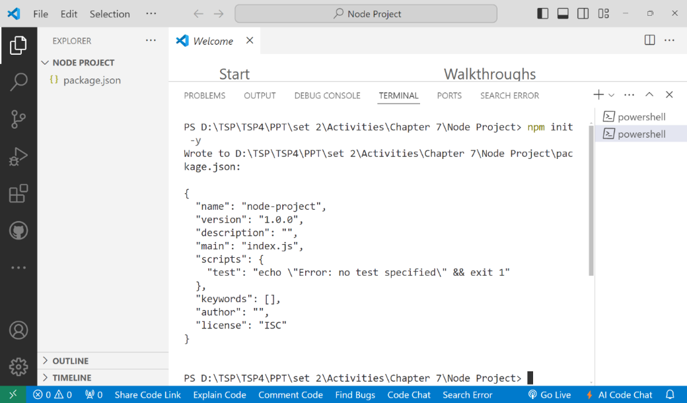

2. **Install Express and Other Dependencies**:

* Install Express and other necessary middleware.

npm install express

